The Philosophies of Thomas Hobbes and John Locke

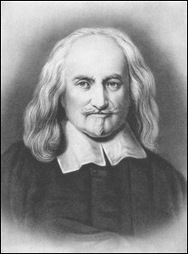
In almost any newspaper or TV news report, on any given day, you can find stories that show Americans grappling with questions about the proper role of government in their lives. These questions are not new. Centuries ago, Thomas Hobbes and John Locke both wrote extensively on these issues. Their ideas, however, differed remarkably. For Hobbes, who viewed humans as basically evil, a government that regulated all kinds of conduct was necessary. Locke, who was more optimistic, saw the need only for more limited government.

Hobbes
Thomas Hobbes was born in 1588 in Gloucestershire (Glouster), England, and began his formal education at the age of four. By the age of six he was learning Latin and Greek, and by the age of nineteen he had obtained his bachelor’s degree from Oxford University. In 1608 Hobbes accepted a position as a family tutor with the earl of Devonshire, a post he retained for the rest of his life.

Hobbes was greatly influenced by the chaos of the English Civil War during the mid-seventeenth century. Its impact is evident in his most famous work, Leviathan (1651), a treatise on governmental theory that states his views on Man and Citizen. Leviathan is commonly described as a book about politics, but it also deals with religion and moral philosophy.

Hobbes characterized humans as selfishly individualistic and constantly at war with one another. Thus he believed that people must surrender themselves to rulers in exchange for protection from their neighbors.

Locke
John Locke, born in England in 1632, was admitted to an outstanding public school at the age of fifteen. It was there that he began to question his upbringing in the Puritan faith. At twenty he went on to study at Oxford, where he later became a lecturer in Aristotelian philosophy. Soon, however, he found a new interest in medicine and experimental science.

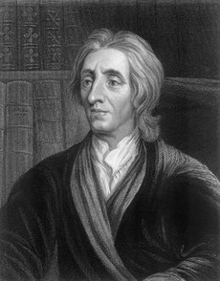
In 1666 Locke met Anthony Ashley Cooper, the first earl of Shaftesbury, and a politician who believed in individual rights and parliamentary reform. It was through Cooper that Locke discovered his own talent for philosophy. In 1689 Locke published his most famous work, Second Treatise on Civil Government, in which he set forth a theory of natural rights. He used natural rights to support his “social contract [theory] - the view that the consent of the people is the only true basis of any sovereign’s right to rule.” A government exists, he argued, because individuals agree, through a contract, to form a government to protect their rights under natural law. By agreeing to be governed, individuals agree to abide by decisions made by majority vote in the resolution of disputes.

Both men, as you can see, relied on wealthy royal patrons to allow them the time to work on their philosophies of government. While Hobbes and Locke agreed that government was a social contract between the people and their rulers, they differed significantly about the proper scope of government. Which man’s views about government (and people) reflect your views?

